

**Data Technician**

|  |
| --- |
|  |

|  |
| --- |
| Name: Danny O’Keefe |
| Course Date: 27Th May 2025 |
|  |

**Table of contents**

Day 1: Task 1 3

Day 1: Task 2 3

Day 1: Task 3 4

Day 2: Task 1 5

Day 3: Task 1 9

Day 3: Task 2 10

Day 3: Task 3 11

Day 4: Task 1 12

Day 4: Task 2 13

1. Scenario Background 13

2. Data Laws and Regulations 14

3. Azure Service Recommendations 14

4. Data Types and Data Modelling 14

5. Data Storage Formats and Structures in Azure 14

6. Additional Considerations 15

Submission Guidelines: 15

Course Notes 17

Additional Information 17

# Day 1: Task 1

Please research and complete the below questions relating to key concepts of cloud.

Be prepared to discuss the below in the group following this task.

|  |  |
| --- | --- |
| How can it benefit a business? | We can use cloud computing in everyday life and in the real-world, for things such as using teams for our daily meetings, or watching Netflix, they use the cloud to store their vast libraries online making selection very simple and fast. Online banking is also used via the cloud to help keep transactions secure. |
| What’s the alternative to cloud computing? | The alternative is on premises computing. |
| What cloud providers can we use, what are their features and functions? | We can use AWS, AZURE or Google Cloud Platform.  AWS is the largest cloud service provider, offering a comprehensive suite of services. Azure is known for its seamless integration with Microsoft products and services. GCP excels in data analytics and machine learning capabilities. |

# Day 1: Task 2

Please research the below cloud offerings, explain what they are and examples of use cases.

|  |  |  |
| --- | --- | --- |
| Cloud Offerings | Explain what it is | When / how might you use this service in the real-world? |
| IaaS (Infrastructure as a service) | Infrastructure as a Service (IaaS) is a cloud computing model that provides on-demand access to fundamental IT resources | Software Dev\testing  Website hosting  Disaster recovery\backups  Big Data Analytics |
| PaaS (Platform as a service) | Platform as a Service (PaaS) is a cloud computing model that provides developers with a comprehensive environment to build, deploy, and manage applications without the complexity of maintaining the underlying infrastructure. | Web\mobile app development  Business analytics/intelligence  Streamlining devops workflows  Hosting Scalable web apps (increased traffic for web apps) |
| SaaS (Software as a service) | Software as a Service (SaaS) is a cloud computing model where software applications are hosted by a service provider and made accessible to users over the internet. It's all done Via subscription. | Customer Relationship Management (CRM)  E-Commerce platforms  Remote work and Collabs  Healthcare (NHS) |

# Day 1: Task 3

Please research the below terms and explain what they are, when they would be appropriate and a real-world example of where it could be implemented (i.e. what type of organisation).

|  |  |
| --- | --- |
| Public Cloud | A public cloud is a cloud computing model where services such as storage, applications, and virtual machines are provided by third-party vendors over the internet. These services are available to multiple users, and the infrastructure is owned and managed by the service provider. Users typically pay on a subscription or pay-per-use basis.  Public cloud solutions are ideal in the real world in scenarios such as the need for global accessibility, Azure can used freely worldwide. Public can also be used for rapid deployment, where companies can aim for quick time-to-market application deployment. It is also cost efficient.  A real-world example of this could be Netflix, which uses a public cloud to deliver content to millions of users globally. By leveraging the scalability and global reach of public cloud providers, Netflix can efficiently manage vast amounts of data and deliver seamless streaming. |
| Private Cloud | A **private cloud** is a cloud computing environment dedicated exclusively to a single organization. It offers the benefits of cloud computing—such as scalability, flexibility, and self-service—while providing greater control, security, and customization compared to public clouds. Private clouds can be hosted on-premises within an organization's own data centre or by a third-party provider.  A private cloud can be useful for companies that handle sensitive data, such as the NHS, as they will benefit from the enhanced security and compliance capabilities. Organisations that need tailored solutions can customise hardware, software and security in a private cloud easily.  Disney created a private cloud using open-source technologies, to support its video game and web properties, and by building their private cloud Disney could easily manage huge amounts of data and, the same as Netflix, provide a seamless experience to its users. |
| Hybrid Cloud | A **hybrid cloud** is a computing environment that combines on-premises infrastructure (private cloud) with public cloud services, allowing data and applications to be shared between them. This setup enables organizations to leverage the scalability and cost-effectiveness of public clouds while maintaining control over critical operations through private clouds.  A hybrid cloud solution is suitable for companies that, again, handle sensitive data and could do with the extra security. They could also be highly useful for companies that require some flexibility, through fluctuating workloads, by scaling up or down quickly all while keeping essential services on-premises.  A notable real-world example of hybrid cloud implementation is Ducati, the renowned Italian motorcycle manufacturer. Ducati adopted a hybrid cloud strategy to enhance its data management and analytics capabilities. By integrating public cloud services with its existing private infrastructure, Ducati achieved improved scalability and performance in processing large volumes of data generated from its racing activities and customer interactions. |
| Community Cloud | A community cloud is a collaborative cloud computing model where infrastructure and resources are shared among several organizations with common objectives, such as regulatory compliance, security requirements, or operational goals. This setup allows organizations to benefit from the advantages of cloud computing—like scalability and cost-efficiency—while maintaining greater control over data and compliance standards compared to public clouds.  Community clouds are suitable when multiple organisations need to share common compliance requirements. Industries such as Healthcare, Finance and Governments often have very tight regulatory standards, and by using a community cloud, this allows them to collectively adhere to such regs. Organizations working on shared initiatives can use a community cloud to facilitate seamless collaboration, data sharing, and communication.  D4Science is a notable example of a community cloud implementation. It is an open science infrastructure that provides virtual research environments for various scientific communities, including agri-food, social data science, earth science, and marine science. By offering shared resources and services, D4Science enables researchers from different organizations to collaborate effectively while maintaining control over their data and compliance with relevant standards. |

# Day 2: Task 1

Describe, with examples, the **three** major areas that the Computer Misuse Act deals with.

|  |  |  |
| --- | --- | --- |
| Area | Description | Example |
| Unauthorized access to computer material. | This offence involves accessing computer systems or data without permission. | Guessing someone's password to log into their email account without their consent. |
| Unauthorised Access with Intent to Commit or Facilitate Commission of Further Offences | This offence occurs when unauthorized access is obtained with the intention of committing or aiding further crimes. | Accessing someone's online banking account without permission to transfer funds illegally. |
| Unauthorised Acts with Intent to Impair, or with Recklessness as to Impairing, the Operation of a Computer | This offence involves actions that intentionally or recklessly impair the operation of computer systems. | Launching a Distributed Denial of Service (DDoS) attack to overwhelm and crash a website. |

The computer misuse act 1990 is an act where an individual can be criminalised because of computer related offense. Describe three extra powers that the Police and Justice Act 2006 (Computer Misuse) has added.

|  |
| --- |
| Description |
| Criminalization of Denial-of-Service (DoS) Attacks - The Act explicitly made it an offence to carry out denial-of-service attacks, which involve overwhelming a computer system to render it unavailable to users. |
| Offence of Making, Supplying, or Obtaining Tools for Computer Misuse - Section 3A was added, making it an offence to create, distribute, or possess tools intended for use in committing computer misuse offences. |
| Increased Penalties for Existing Offences - The Act increased the maximum penalties for offences under the Computer Misuse Act. |

Look at the below website to answer the questions:

<https://www.gov.uk/personal-data-my-employer-can-keep-about-me>

|  |
| --- |
| Write down three items of data which a company can store about an employee. |
| Name |
| Address |
| Date of Birth |

|  |
| --- |
| Give three more examples of data that an employer can only store if they first get the employee’s permission. |
| Race |
| Religion |
| Political Views |

Conduct further research to answer the below questions.

|  |  |
| --- | --- |
| Question | Answer |
| Provide one example of: Copyright infringement | Copyright infringement occurs when someone uses, reproduces, distributes, or displays a copyrighted work without the permission of the copyright holder, violating the exclusive rights granted to the creator. These rights include the ability to reproduce, distribute, perform, display, and create derivative works based on the original creation. |
| Provide one example of: Plagiarism | Plagiarism is the act of using someone else's work, ideas, or expressions without proper acknowledgment, presenting them as your own. This unethical practice undermines academic integrity and can have serious consequences in educational, professional, and creative fields. |
| What are two consequences of copyright infringement and software piracy? | Civil and criminal penalties  Reputational Damage |
| Give three possible consequences for individuals when using pirated software | Legal and financial repercussions  Exposure to malware and cyber threats  Reputational damage, potential career ender! |

Listed below are some laws which we have covered today:

1. Computer Misuse Act 1990

2. Police and Justice Act 2006 (Computer Misuse)

3. Copyright, Designs and Patents Act 1988

4. Copyright (Computer Programs) Regulations 1992

5. The Health and Safety (Display Screen Equipment) Regulations 1992

6. Data Protection Act 2018

7. Consumer Rights Act 2015

* Insert a number in the first column of each row to match each of the statements with one of the above Acts.
* One of statements is incorrect and not illegal. For this statement, write ‘Not illegal’.

|  |  |
| --- | --- |
| **Act number** | **Clause** |
| 3. or 4. | With some exceptions, it is illegal to use unlicensed software |
| 7. | Any product, digital or otherwise, must be fit for the purpose it is supplied for |
| 1. | Unauthorised modification of computer material is illegal |
| Not Illegal | It is illegal to create or use a hacking tool for penetration testing |
| 6. | Personal data may only be used for specified, explicit purposes |
| 5. | Employers must provide their computer users with adequate health and safety training for any workstation they work at |
| 2. | It is illegal to distribute hacking tools for criminal purposes |
| 3. | It is illegal to distribute an illicit recording |
| 6. | Personal data may not be kept longer than necessary |
| 1. | Gaining unauthorised access to a computer system is illegal |
| 5. | Employers must ensure that employees take regular and adequate breaks from looking at their screens |
| 2. | It is illegal to prevent or hinder access (e.g. by a denial-of-service attack) to any program or data held in any computer |
| 6. | Personal data must be accurate and where necessary kept up to date |

# Day 3: Task 1

Please complete the below lab (3) *‘Explore relational data in Azure’* and paste evidence of the completed lab in the box provided.

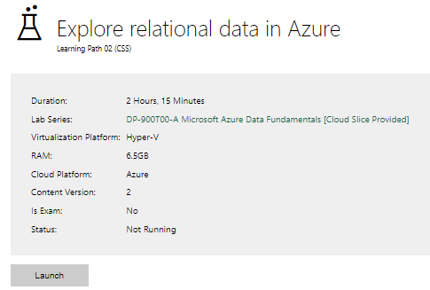

|  |  |
| --- | --- |
| Completed lab |  |

Complete the exercises below if finished early. [Azure Lab 1 Exercises](https://forms.office.com/e/kz2sCX75fc)

# Day 3: Task 2

Please complete the below lab (4) *‘Explore non-relational data in Azure’* and paste evidence of the completed lab in the box provided.

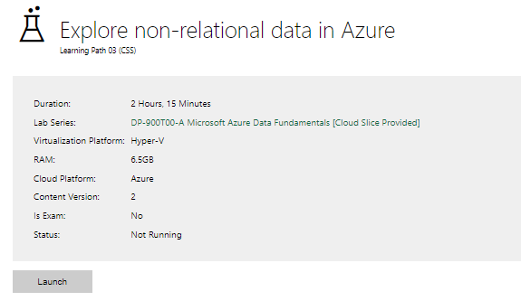

|  |  |
| --- | --- |
| Completed lab |  |

# Day 3: Task 3

Please complete the below lab (5) ‘Explore data analytics in Azure’ and paste evidence of the completed lab in the box provided.

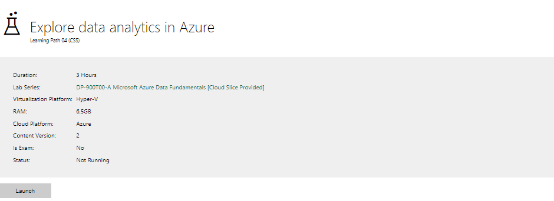

|  |  |
| --- | --- |
| Completed lab |  |

# Day 4: Task 1

In your teams, complete the Azure DP-900 practice exam and paste your result below – this is open book and please research and discuss your answers as a team.

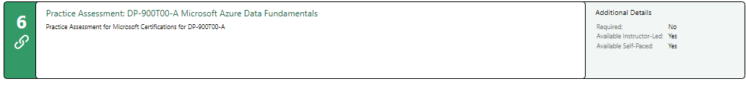

|  |  |
| --- | --- |
| Result |  |

# Day 4: Task 2 (Optional)

#### **1. Scenario Background**

"Paws & Whiskers" is a growing pet shop that aims to improve its business by analysing sales, customer information, and inventory data. Currently, the data is collected manually or stored in spreadsheets. Management is interested in transitioning to Microsoft Azure to streamline data storage, analysis, and reporting, enabling them to make data-driven decisions.

#### **2. Data Laws and Regulations**

Identify and explain the data laws and regulations relevant to handling customer data within the proposal. Ensure you cover the following points:

* **GDPR Compliance**: Highlight the importance of adhering to the General Data Protection Regulation (GDPR), particularly as it relates to storing and processing customer information.
* **Data Protection Act (DPA) 2018**: Outline how the DPA 2018 may affect the way "Paws & Whiskers" collects and stores data, ensuring compliance with UK laws on data privacy.
* **Other Industry Standards**: Research any additional data protection standards or regulations that may apply to pet shop data, particularly if they involve sensitive or payment information.

#### **3. Azure Service Recommendations**

Recommend Microsoft Azure services that would suit the company’s data analysis needs and explain why these services are suitable. Your recommendations should include:

* **Data Storage**: Identify suitable storage options, such as **Azure Blob Storage** or **Azure SQL Database**, and discuss the benefits of each for storing large datasets, including inventory, sales transactions, and customer details.
* **Data Analysis Tools**: Recommend tools such as **Azure Machine Learning** for customer behaviour analysis or **Azure Synapse Analytics** for analysing sales trends.
* **Data Integration and Automation**: Explain how services like **Azure Data Factory** could automate data collection and integration processes, improving efficiency.

#### **4. Data Types and Data Modelling**

Define the types of data "Paws & Whiskers" will need to work with and describe your approach to data modelling:

* **Data Categories**: Identify key data types, such as customer demographics, transaction history, pet inventory, and product categories.
* **Data Modelling Approach**: Outline how you would structure this data using a relational model or a data warehouse approach, considering factors like tables, entities, relationships, and primary keys.

#### **5. Data Storage Formats and Structures in Azure**

Discuss how you would store data within Azure and the formats you would recommend:

* **Data Formats**: Specify recommended formats (e.g., CSV for raw data imports, JSON for structured data, Parquet for analytics) and explain why these formats are suitable for specific data types.
* **Data Security and Encryption**: Include recommendations for securing data using Azure’s built-in encryption features and access controls to ensure compliance with data privacy regulations.

#### **6. Additional Considerations**

Provide any other considerations that might enhance data handling and efficiency in Azure, such as:

* **Backup and Disaster Recovery**: Outline a backup plan using **Azure Backup** or **Azure Site Recovery** to safeguard against data loss.
* **Data Visualisation**: Discuss potential use of **Power BI** within Azure for creating dashboards that provide management with real-time insights into sales and customer trends.
* **Future Scalability**: Comment on how Azure services can scale as the business grows, accommodating larger datasets and more complex analyses.

### **Submission Guidelines:**

1. **Structure**: Ensure your report is well-organised, with sections for each task (e.g., Data Laws, Azure Services, Data Types, etc.).
2. **Formatting**: Include headings, bullet points where appropriate, and any visuals or diagrams that support your explanations.
3. **References**: Cite any resources or regulations referenced in the report.
4. **Length**: Aim for 1500-2000 words.

|  |
| --- |
|  |

|  |
| --- |
| **Course Notes** |

It is recommended to take notes from the course, use the space below to do so, or use the revision guide shared with the class:

|  |
| --- |
| **Additional Information** |

We have included a range of additional links to further resources and information that you may find useful, these can be found within your revision guide.

**END OF WORKBOOK**

**Please check through your work thoroughly before submitting and update the table of contents if required.**

**Please send your completed work booklet to your trainer.**